- Copyright for test papers and marking guides remains with West Australian Test Papers.
- The papers may only be reproduced within the purchasing school according to the advertised conditions of sale.
- Test papers must be withdrawn after use and stored securely in the school until Friday 4th December 2015.



HUMAN BIOLOGICAL SCIENCE
UNITS 1 & 2

2015

MARKING GUIDE

Multiple choice

1 | A | 11 | B | 21 | D
2 | B | 12 | A | 22 | B
3 | B | 13 | B | 23 | C
4 | A | 14 | A | 24 | C
5 | C | 15 | B | 25 | B
6 | C | 16 | B | 26 | D
7 | D | 17 | A | 27 | B
8 | C | 18 | D | 28 | A
9 | A | 19 | C | 29 | A
10 | D | 20 | D | 30 | B

Short Answer

Question | Content | Marks
31 a | 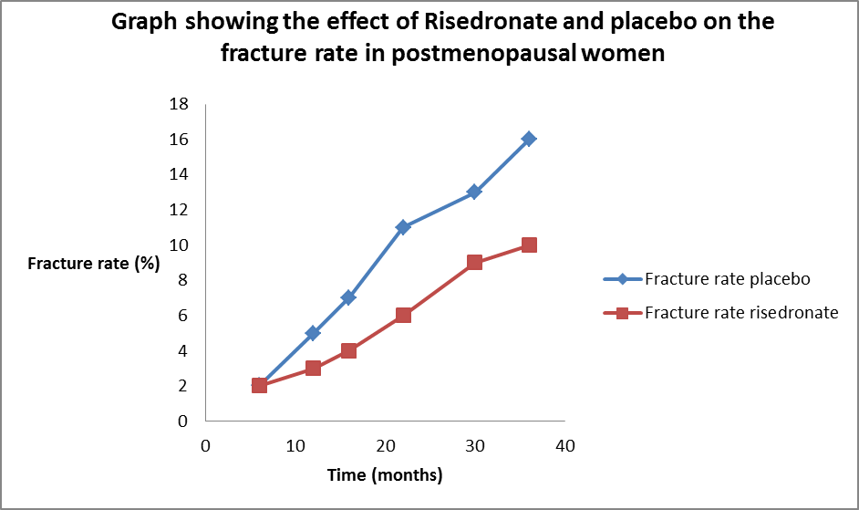  Title with independent and dependent variable included (1)  Key (1)  X-axis scale correct (0.5)  Y-axis scale correct (0.5)  Labels on x-axis with units(1)  Labels on Y-axis with labels (1) | 5
31 b | Eg.Risedronate will reduce the fracture rate in postmenopausal women over a 3 year period  Linking independent and dependent variables (1)  Hypothesis states a direction e.g. Increase or decrease (1) | 2
31 c | To allow for the women to be unaware of which substance they are taking and thus biasing the results (Blind trial conditions) / to provide a baseline for comparison allowing conclusions about the effects of Risedronate to be drawn | 1
31 d | Any 2 of the following:  • All fractures must be diagnosed by the same doctor to control for any differences in opinion  • All women should have an official diagnosis of osteoporosis  •All women are not to be taking any other medication or supplements which may affect their fracture rate. | 2
31 e | Answer in the range 11 – 13 | 1
31 f | After 6 months the fracture rate was 2% in both groups. (1)  Between 6 months and 36 months the fracture rate was reduced in the group receiving Risedronate compared to the placebo group (1) | 2
32 a | changes in an organism caused by modification of gene expression rather than alteration of the genetic code itself. | 1
32 b | Diet, Chemicals eg. alcohol, cigarette smoke, Stress | 1
32 c | - Addition of a methyl group (1)  Methylation results in the DNA becoming more tightly wound around the histones (1)  - This reduces the ability of the RNA polymerase to bind to the DNA(1)  Protein synthesis cannot occur / gene is switched off/gene is silenced/gene is no longer expressed (1) | 4
32 d | Any 2 processes explained:  Crossing over (1) Chromosomes exchange genetic material when paired up in prophase 1 / metaphase 1 creating a different combination of genes(1)  Independent assortment (1)  Homologous chromosomes align differently or switch positions when moving to the equator of the cell during metaphase 1 resulting in different combinations of chromosomes moving into cells in the first meiotic division(1).  Non-disjunction (1)  Homologous chromosomes or sister chromatids may not separate evenly into each gamete, as a result the gametes formed may have unequal numbers of chromosomes.(1) | 4
32 f | Stage A(1)  During Anaphase 1 the homologous chromosomes have been separated due to the spindle fibres attaching to and pulling on each chromosome of the pair. The chromosomes are moving to opposite poles of the cell. (1) | 2
33 a | Y – Cervix (1)  Z – Endometrium (1) | 2
33 b | Ovulation (1)  Stimulated by the increased levels of LH (1) | 2
33 c | Any 3 of following: (1 mark each)  - The placenta limits the transfer of materials to eliminate the possibility of immune rejection by the mothers immune system  - Transfer of oxygen – aided by foetal haemoglobin that has a high affinity for oxygen  - Transfer of Soluble nutrients- glucose, amino acids  - Removes Urea and carbon dioxide as wastes  - Antibodies pass in the later stages of pregnancy  - Produces HCG – maintains corpus luteum for the first 3 months  - Produces Oestrogen and progesterone increases as the corpus luteum degenerates  - Human placental lactogen – promotes milk production  - Produces Prostaglandins – (directed by foetal adrenal steroid hormones) stimulators of contractions of the smooth muscles of the uterus for birth.  - Produces protective molecules that cover the surface of the early placenta to camouflage the early embryo from the maternal immune rejection system. | 3
33 d | Any 2 – max 2 for naming  Foramen Ovale (1)  Allow blood to cross from the right atrium to the left atrium as the lungs are not operational and blood entering the heart is the oxygenated (1)  Ductus Venosus (1)  Allows blood to bypass the liver and return directly to the heart (1)  Ductus Arteriosus (1)  Allows oxygenated blood to bypass the non-functional lungs and flow  directly into the aorta and to the body (1).  Umbilical Artery/Vein (1)  Umbilical artery contains deoxygenated blood with wastes and the umbilical vein contains oxygenated blood with nutrients.(1) | 4
34 a | - Ribose Sugar and phosphate correctly labelled (1)  - Adenine (0.5)  - Cytosine (0.5) | 2
34 b | mRNA is transcribed from the DNA template in the nucleus (1)  mRNA carries the code out to the ribosome where amino acids are assembled to form protein (1) | 2
34 c | Any 3 of the following:  mRNA binds to the ribosome (1)  First codon is read, Transfer RNA (tRNA) with its matching anticodon, carries an appropriate amino acid to the mRNA(1)  Second codon is read and second tRNA carries an amino acid to the mRNA ribosome (1)  Peptide bond is formed between the two amino acids and the first tRNA leaves the ribosome (1). | 3
35 a | Any 2  active / energy is required in the form of ATP  moves substances against concentration gradient / from low to high concentration  uses carrier / channel proteins in the cell membrane | 2
35 b | Oxygen and glucose (1)  Oxygen enters the cell through the cell membrane by simple diffusion (1)  Glucose enters the cell through facilitated diffusion (1) | 3
35 c |  | 1
  - 6.7
  5.2
  0.1
35 d | Egg A (1)  Solution is beaker is hypertonic / concentration of water molecules higher outside the egg than inside the egg / lower water potential (1)  Therefore water moves out of the egg by osmosis (1)  from an area of high concentration of water molecules to an area of low concentration of water molecules / from an area of high to low water potential (1) | 4
36 a | Haversian Canal  Canaliculi  Lacunae  Lamellae | 4
36 b | Any 2 symptoms (1 mark each)  Pain in joints  Stiffness and reduced mobility in joints  Inflammation of joint area  Deformation of joints  Any 1 treatment (1 mark)  Paracetamol and non-steroidal anti-inflammatories e.g Nurofen  Cortisone injections into joint reduce inflammation  Finger splints or knee braces, can reduce stress on the joints and ease pain.  Arthroscopic surgery to remove bone spurs, remove loose bodies, or smooth the cartilage.  Joint replacement surgery | 3
36 c | - Ball and socket(1)  Circumduction (1)  - Hinge (1)  Extension and flexion / movement on one plane only (1)  - Any 1 of the following:  Freely moveable (1)  Synovial fluid present(1)  Articular cartilage present(1)  - Antagonistic pair of muscles (1)  Bicep muscle contracts / is the flexor (1)  Tricep muscle relaxes relaxes/is the extensor (1) | 8
37 a | Any 2 (1 mark each)  Proteins  Biological catalysts / speed up the rate of reactions  Specific to a substrate  Active site to which substrate binds | 2
37b | - Graph shows rate increasing to a peak (1) and then sharply decreasing to 0 (1)  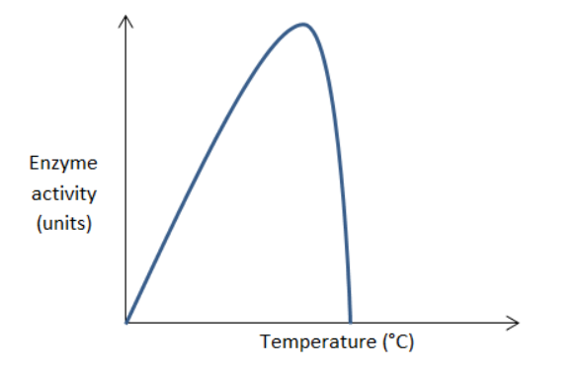  - At low temperatures there are few collisions between enzyme and substrate so the enzyme activity is low (1)  As temperature increases towards the optimum temperature enzyme activity increases due to increased number of collisions between substrate and enzyme (1)  At temperatures above the optimum, Enzyme activity stops as enzyme denatures / changes to the shape of active site (1) | 5
37 c | Emulsification (1) increased surface area / produce smaller droplets (1) | 2
37 d | Peristalsis (1)  Rhythmic muscular contractions of the alimentrary canal walls (1) | 2
38 a | Any 1  Veins have valves, arteries don’t  Veins have a wider lumen  Arteries have a thicker layer of muscle in the wall | 1
38 b | Any 2:  Dissolved in solution (1)  Bound to haemoglobin / as carbaminohaemoglobin (1)  As bicarbonate ions (1) | 2
38 c | Oedema / swelling of extremities (1)  Prevention of drainage/removal of tissue fluid / water retained in tissue fluid due to build up of solutes OR low water potential;(1) | 2
38 d | Atrioventricular vales / bicuspid and tricuspid valves close  Ventricle walls contract  Semi lunar valves forced open | 3
38 e | Thrombocytes – involved in blood clotting (1)  Leucocytes – defend the body against pathogens / immune response (1)  Plasma – carries dissolved substances (1) | 3
38 f | A Rh + (0.5) A Rh- (0.5) O Rh+ (0.5) O Rh- (0.5) | 2
38 g | Any 2:  Cells may clump together / agglutination (1)  Cell clumping can prevent oxygen delivery to cells / increase blood viscosity (1) | 2
38 h | Key or statement indicating codominance of alleles A and B to recessive allele O (1)  Parental genotypes OO x AB (1)  Correct punnett square (1)  F1 genotypes: 50% OA, 50% OB or AO:OB 1:1 ratio (1)  F1 phenotypes: 50% Type A, 50% Type B or Type A: Type B 1:1 ratio (1) | 3
   | A | B
  O | OA | OB
  O | OA | OB

Extended response

Question | Content | Marks
39 a | Female Oogenesis occurs in the ovaries (1)  Male – Spermatogenesis occurs in the testes (1)  Compare processes and products – Any four points for (4)  both involve meiosis  both involve cell proliferation / mitosis (before meiosis)  both involve cell growth /enlargement (before meiosis)  LH /FSH involved in both  Both occur in gonads  Contrast processes and products – Any four points for (4)  spermatogenesis starts at puberty versus oogenesis starts in the fetus  spermatogenesis until death versus oogenesis until menopause  millions of sperm versus one egg per month  ejaculation of sperm any time versus ovulation in middle of menstrual cycle  four sperm per meiosis / spermatogenesis versus 2 or 3 polar bodies in oogenesis  spermatogenesis involves equal divisions versus oogenesis involves unequal cell / cytoplasm divisions  no polar bodies in speratogenesis versus 2 or 3 polar bodies in oogenesis  meiosis II completed before fertilization in spermatogenesis versus after in oogenesis | 10
39 b | Any two of the following:  IVF  Process - A procedure whereby an egg (or more than one egg) is retrieved from the body of a woman and combined with sperm outside the body to achieve fertilisation. (1)  Use – Conceiving/fertilisation is not occurring naturally in the body (1)  Risks – Any reasonable risk (1)  Benefit – Any reasonable benefit(1)  Ethics – Most often there needs the woman will need to provide a lot of eggs, and then what happens to the eggs? (1)  Artificial insemination  Process - A procedure where human sperm are introduced, by a non-coital method, into the reproductive system of a woman(1)  Use - When male sperm count is low or the male is having erectile problems(1)  Risks – Any reasonable risk(1)  Benefit – Any reasonable benefit(1)  Ethics – Anonymity/Rights of the donor(1)  Gamete Intrafallopian transfer  Process - A procedure where an egg (or more than one egg) retrieved from the body of a woman and sperm obtained from a male are both inserted back into the fallopian tube of a woman, (1)  Use – When a female is having difficulty with implantation. Fertilisation process is not occurring. (1)  Risks – Any reasonable risk(1)  Benefit – Any reasonable benefit(1)  Ethics – Most often there needs the woman will need to provide a lot of eggs, and then what happens to the excess eggs? (1)  Intracyclic sperm injection  Process - An IVF technique where to achieve fertilisation a single sperm is injected directly into an egg. (1)  Use - When male sperm count is low. (1)  Risks – Any reasonable risk(1)  Benefit – Any reasonable benefit(1)  Ethics – (1)  ZIFT  Process - involves ovarian stimulation, monitoring and egg retrieval. Sperm are collected, specially processed and used to fertilize the egg in vitro. If fertilization takes place, those eggs that have been fertilized (thus becoming zygotes) are transferred into the fallopian tubes rather than the uterus. (1)  Use – When a female is not ovulating or her ovum numbers are low. (1)  Risks – Any reasonable risk(1)  Benefit – Any reasonable benefit(1)  Ethics – Most often there needs the woman will need to provide a lot of eggs, and then what happens to the eggs? (1)  What should be done with the frozen embryos?  How are the embryos disposed and can they be used for medical research. | 10

Question | Content | Marks
40a | Any 8  Diffusion from air inside alveoli into blood through alveolar wall  Movement from area of high concentration to area of low concentration  Diffusion into erythrocyte  Where oxyhaemoglobin is formed  Some oxygen (3%) dissolved in blood plasma  Blood in capillaries enters venules  Blood leaves lungs via pulmonary vein  Enters left side of heart into left atrium  Blood passes through bicuspid / atrioventricular valve into left ventricle  Blood exits heart through semi lunar valves into aorta  Aorta divides into arteries then arterioles  At tissues arterioles divide into capillaries  oxygen dissociates from the haemoglobin  Oxygen diffuses through capillary wall into muscle cells | 8
40b | FSH stimulates the development and maturation of the ovarian follicle (1)  The ovarian follicle then secretes oestrogen (1)  Oestrogen maintains the female reproductive system (1)  High oestrogen inhibits FSH release/stops another follicle from developing in the ovary (1)  LH causes maturation of the follicle/triggers ovulation/causes formation of corpus luteum (1)  The corpus luteum now releases progesterone (1)  Progesterone maintains the endometrium (1)  As progesterone levels increase, LH is inhibited (1)  If implantation occurs, progesterone levels continue to increase (1)  This inhibits further development of follicles in the ovary (1)  If implantation does not occur, progesterone levels decrease (1)  Pituitary gland releases FSH and another follicle begins to mature in the ovary. (1)  Hormonal contraceptives contain synthetic oestrogen and or progesterone. They work by:  - Preventing the release of mature eggs from the ovary / ovulation  - Increase the thickness of cervical mucus which makes it difficult for sperm to travel up from the vagina  - Alter the uterine lining so it is less receptive to implantation of embryo | Up to 10 marks  Up to 2 marks

Question | Content | Marks
41a | Max 5 for digestion  Action of salivary amylase/carbohydrase in the mouth  Mechanical digestion by teeth / mastication  Starch broken down to maltose / polysaccharide to disaccharide  No chemical digestion in stomach due to pH denaturing enzymes  Pancreatic amylase / carbohydrase continue digestion in the duodenum  Starch broken down to maltose / polysaccharide to disaccharide in duodenum  Intestinal amylase/carbohydrase (or named enzyme) digests disaccharides into monosaccharides / maltose into glucose  Max 7 for absorption  Glucose is a small soluble molecule  Absorption takes place in small intestine / ilium  Which is highly folded and have  Projections called villi and microvilli  Which provide a large surface area  Thin walls  Extensive blood supply  Glucose moves into the villi by active transport  Glucose then moves in to the capillaries inside the villi | 12
41b |  | 8
  Contrast | Aerobic Respiration | Anaerobic respiration
  Location | Mitochondria(1)  (starts in cytoplasm) | Cytoplasm(1)
  Reactants | Glucose and oxygen(1) | glucose(1)
  Products | Carbon dioxide  Water  Energy in the form of ATP  (1) | Lactic acid  Energy in the form of ATP  (1)
  Amount of energy produced | 36 – 38 ATP per glucose(1) | 2 ATP per glucose(1)

